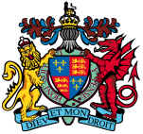
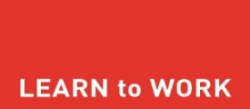
King Edward VI Lordswood School for Girls
Year 10 Work Experience 2025
Own Placement Form

Student Details (Capital letters)

Full Name _______________________________________________________

Tutor Group _____________ Email ________________________________

DOB _____________ Mobile ________________________________

Placement Details (Capital letters)

Business Name ____________________________________________________

Full Address ______________________________________________________
______________________________________________________
_____________________________ Postcode _________________

Telephone ______________________ Mobile __________________________

Email address _____________________________________________________

Type of work ______________________________________________________

Working Hours Start time: ______________ Finish time: _________________

(6 hours a day minimum, latest finish time 8 pm)

Dress Code ______________________________________________________

Special Requests ___________________________________________________

Name of contact person _____________________________________________________(please print)

Signature ____________________________ Date______________________

* FORM MUST BE HANDED IN BY MONDAY 3 FEBRUARY *
TAKE A PHOTO OF YOUR COMPLETED FORM AND HAND IT IN TO THE ‘WORK EXPERIENCE’ BOX AT STUDENT RECEPTION
PLACEMENT DATES: MONDAY 16 – FRIDAY 20 JUNE 2025

